

**ST. MARY’S SCHOOL SUNDERNAGAR**

**COMPUTER SCIENCE PROJECT**

**2022-23**

**SUBMITTED BY: SUBMITTED TO:**

**NAME:**  MRS.PAYAL JAMWAL

**ROLL NO.**

**CLASS: 12th**

**CERTIFICATE**

This is to certify that a student of class 12th has successfully completed their computer science project on

“**HOTEL MANAGEMENT SYSTEM**”

under the guidance of computer science teacher **Mrs. Payal Jamwal.**

**PRINCIPAL**

**EXTERNAL EXAMINER** **INTERNAL EXAMINER**

**ACKNOWLEDGEMENT**

In the accomplishment of this project synopsis successfully, many people have bestowed upon me their blessings and the heart pledge support, this time I am utilizing to thank all the people who have been concerned with this synopsis. Primarily I would like to thank **God** for being able to complete this synopsis with success. Then I would like to thank my Computer Science teacher **Mrs. Payal Jamwal** ma’am whose valuable guidance has been the one that helped me patch this project and make it full proof success, her suggestions and instructions have served as a major contribution towards the completion of this synopsis.

Lastly, I would like to thank **my parents** who have helped me with their valuable suggestions and support which has been very helpful in various phases.

**INDEX**

|  |
| --- |
| * Introduction |
| * About Python |
| * About MySQL |
| * Databases used |
| * Source Code |
| * Outputs |
| * Bibliography |

**Introduction**

A hotel is a place where people go to stay over night. People often choose to stay at a hotel, whether they're traveling or not. Many choose to stay at a hotel when they're out on business. Hotels have many facilities to accommodate the needs of their guests. One important factor in the success of a hotel is the management of the staff and operations. The success of a hotel is largely dependent on the management system used to run the establishment.

Operations management is an important aspect of running a hotel. Most tasks that need to be completed during business hours are difficult without modern technology. Computers allow managers to organize their staff and manage their daily activities more efficiently. It's also easy for managers to keep track of the performance of their staff members. This way, they can give bonuses to good workers and dismiss underperforming employees. Overall, computers make running a hotel much easier and more profitable. This can be done easily with the help of many softwares known for DBMS and RDBMS.

MySQL

One such software is MySQL. MySQL, or MariaDB as it is sometimes known, is a relational database management system (DBMS) that is part it is the most widely used open-source database engine in the world. It's free and open-source, so it's a powerful tool for both individuals and organizations. MySQL has a strong focus on data integrity, security and performance. It's considered a multi-threaded and multi-processed engine, which makes it efficient and capable of handling multiple tasks at once.

MySQL has many strengths. First, it's free and can be used without limits on storage space. This allows you to store large amounts of data without paying extra fees. Second, MySQL has numerous built-in features for managing tables using keys, indexes and triggers. This makes your databases more secure and allows you to easily create custom applications. Third, MySQL has an easy-to-use and extensible programming language called SQL. This allows you to create complex queries with ease. Many people consider MySQL one of the best open-source projects available.

Python

Python is a dynamic programming language originally created by Guido van Rossum. It is an open source programming language with many users. It is easy to learn and is a tool used by many software engineers. A key feature of Python is that it is easy to understand and modify. It is a versatile language that can be used for various projects. Python is easy to learn and use. This makes it a great language for developing software. Since it is easy to learn and use, many people use it for basic programming tasks. Additionally, it is an excellent choice for teaching other languages to programmers. This allows people to learn how to code by using Python as the base language. This makes software development faster, easier, and more effective.

Python is a widely used language. It's popularity stems from the fact only few people know the language, making it a rare commodity in the software community. As such, when people hear about a new programming language they typically interpret that language as they wish. In other words, if they like Java they'll code in Java, if they like C# they'll code in C# and so on. However, Python has a large and growing user base thanks to its portability and ease of use.

Top of Form

Database And Tables:

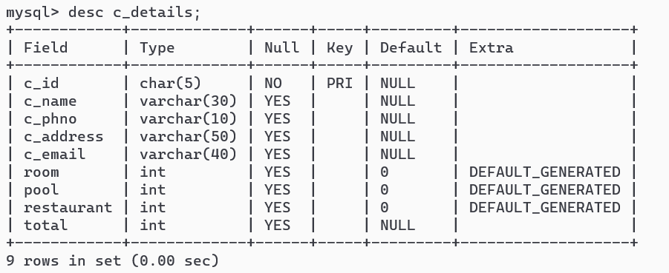

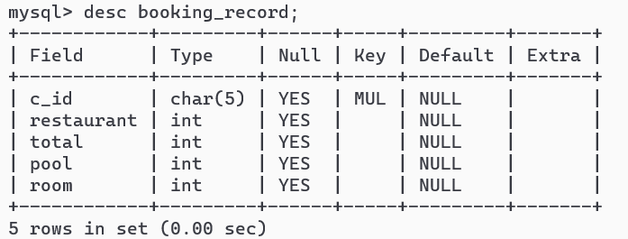

Source Code:

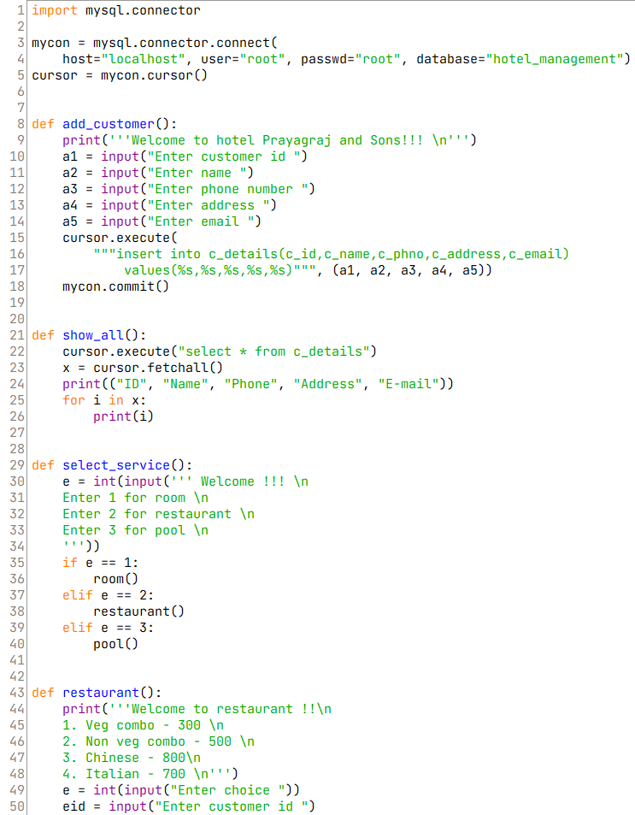

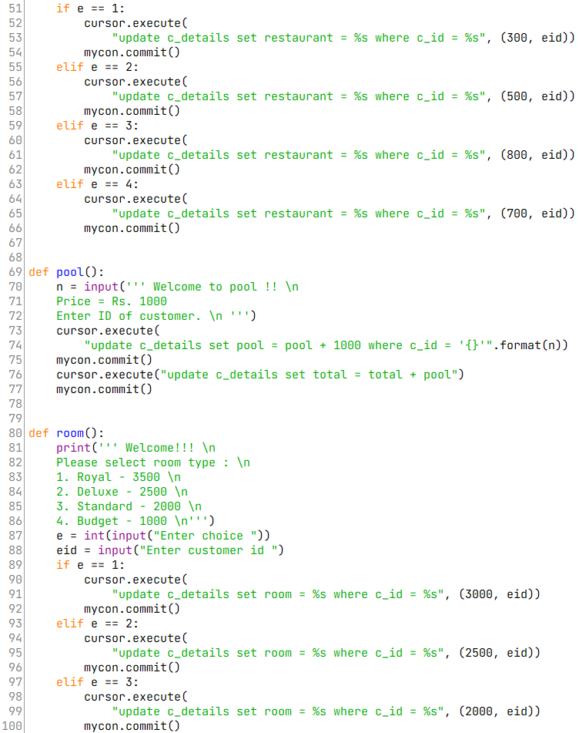

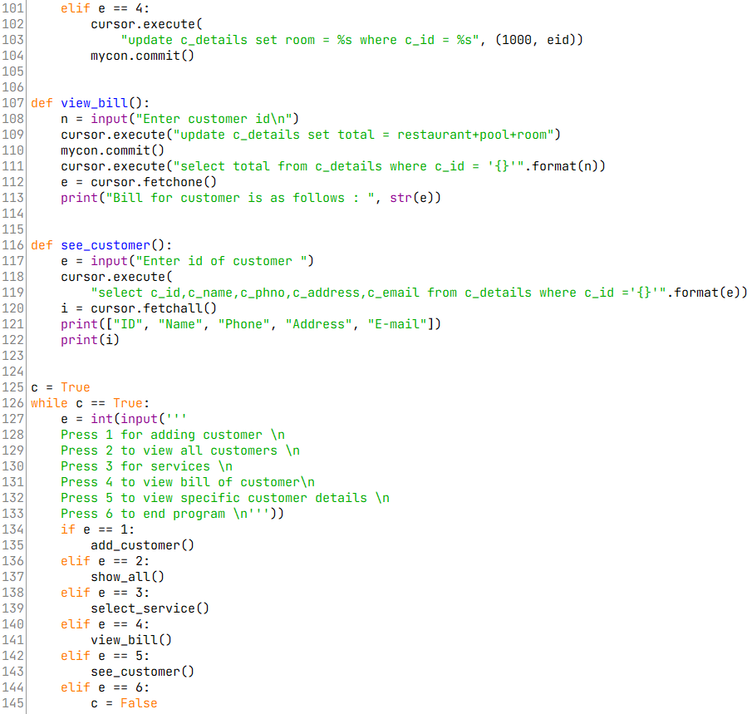

Output:

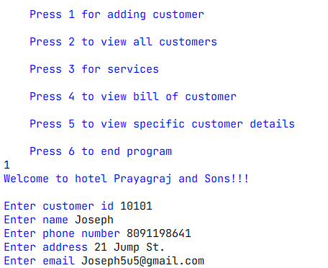

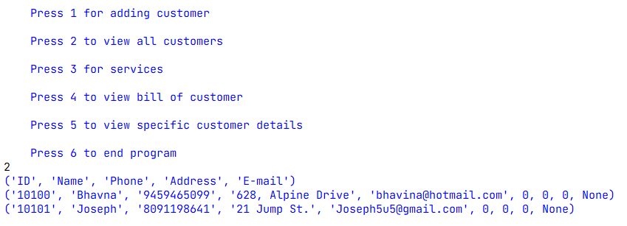

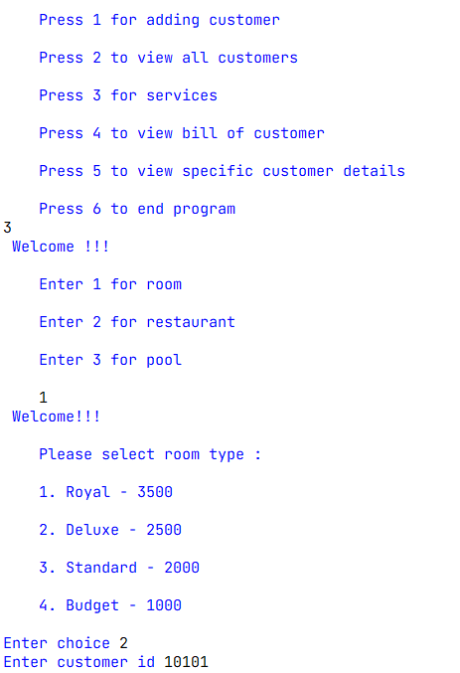

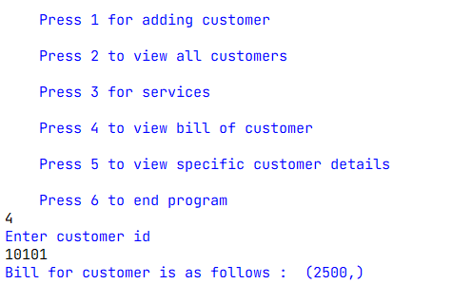

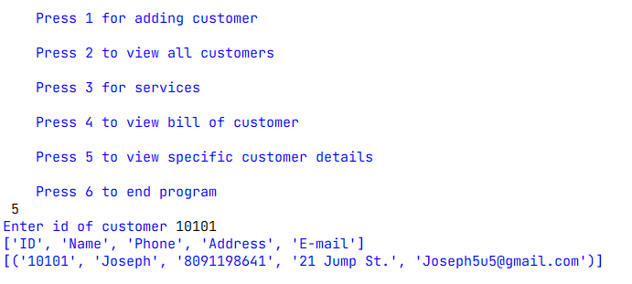

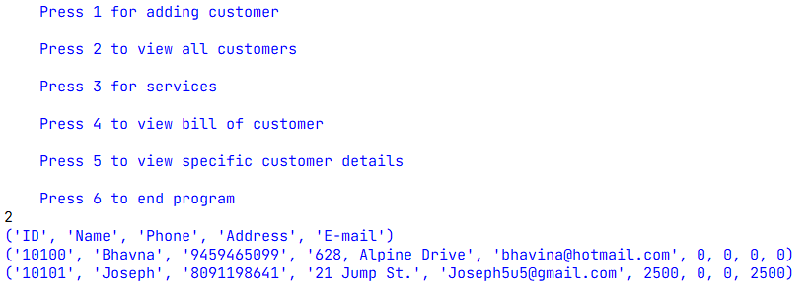

Bibliography:

* [**www.google.com**](http://www.google.com)
* **stackoverflow.com**
* **www.wikipedia.org**
* **Computer Science with Python Class 12th by Sumita Arora**

https://www.youtube.com/watch?v=NkFrnFooMgk